**SC1 W**

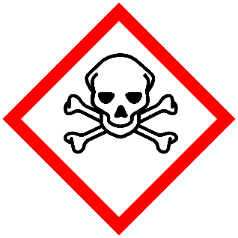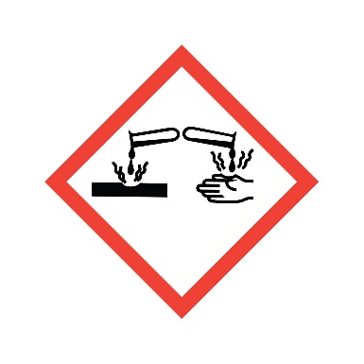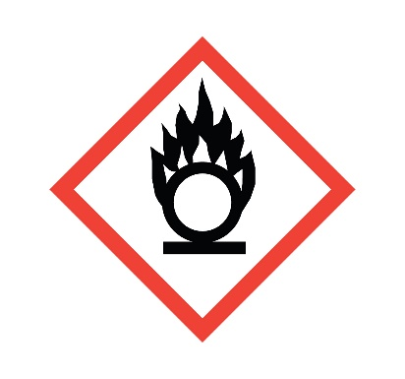

**Danger**

Causes severe skin irritation and eye damage.

**Composition**

**3% H2O2 + NH4OH**